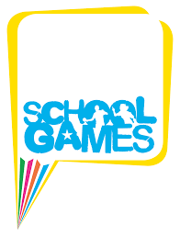

CODE OF CONDUCT
Code of Conduct for Parents/ Spectators
- Remember that children paly sport for their own enjoyment, not yours
Do
- Encourage in your support
- Encourage them to play by the rules
- Discourage unfair play and arguing with officials
- Applaud effort and good play as well as success
- Teach children that winning isn’t the be all and end all
- Set a good example- applaud good play by ALL
- Accept officials’ decisions and teach children to do likewise
- Be Courteous to all
- Show appreciation of all volunteers, officials and coaches

- Ridicule or yell at a child for making a mistake or losing a game- mistakes are a part of learning
Don’t
- Abuse or yell at officials, coach/teacher or volunteer- young players can’t play the game without them
- Force your child to take part in sport
- Threaten or intimidate
- Use inappropriate language
- Confuse the players by telling them what to do or coaching them- let the teacher/coach do their job
- Do anything which is likely to offend by way of insult, humiliation or discrimination

