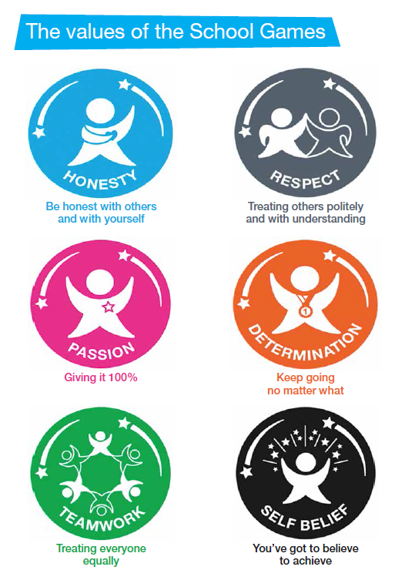

**SPIRIT OF THE GAMES**





**This Certificate is awarded to**

**…………………………………………..**

**for demonstrating**

**…………………………………………..**

**Giving every young person a sporting chance**