**Intro to Judging Gymnastics Course**

**Monday 15th January 2017 4.00-6.00pm**

**@ Milton Community Centre**

Aimed at 11-16 year olds this course is the first step on the judging pathway enabling attendees to have a better understanding of the role of a judge in gymnastics and the principles of judging. On completion attendees will be able to judge at low level competitions & events. 

**ALL BOOKING FORMS NEED TO BE IN BY 15th DECEMBER**

**Cost:** £25 (cheques made payable to Comberton Village College)

We can subsidise the cost to £10 if you commit to judging at a School Games Key Steps Gymnastics Competitions. (Wednesday 31st January 1-3pm at NCA or Thursday 22nd March 10am-2pm at Hunts Gym)

**To book a place on this course please complete a registration form and return it along with payment to:**

Vicky Jonas, South Cambs SSP, Comberton Village College, West Street, Comberton CB23 7DU Tel: 01223 264470 ext 225 or email [sspadmin@combertonvc.org](mailto:sspadmin@combertonvc.org)

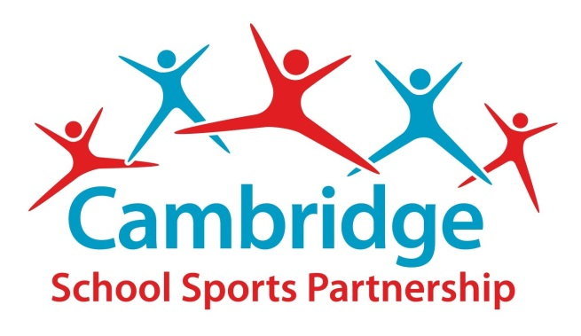

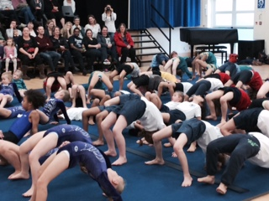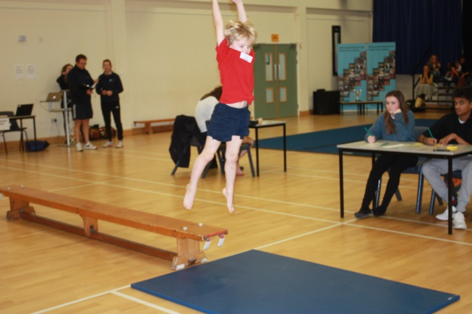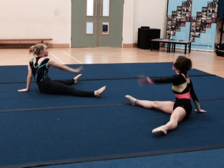

**Giving every young person a sporting chance**