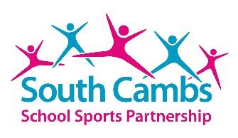
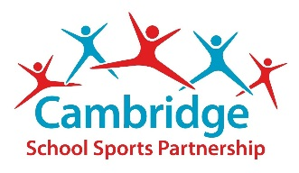
Young Leaders
Young leaders is a programme designed to help your school create an active lunchtime for younger children and to develop the leadership skills of the children in upper Key Stage 2.
Who?
The programme is aimed at Year 5/6 pupils.

What?
Training is delivered by a member of SSP staff and consists
of a 2 hour session with groups of up to 20 children.

Where?
Training is delivered in a school hall/ classroom for the theory
then outside for the practical.

How much?
£120
Contact us:
Lisa Woolfe csspadmin@netherhall.cambs.sch.uk
01223 242931 ext 267
www.cambridgessp.com

“Learning to be a leader is an invaluable life skill allowing children to learn the importance of communication & responsibility.”
Young leader training is linked to our midday supervisor training to help you create an active playground. Young leaders will develop:
- An understanding of the importance of an active playtime
- Improved communication and organisation skills
- Increased confidence and greater responsibility
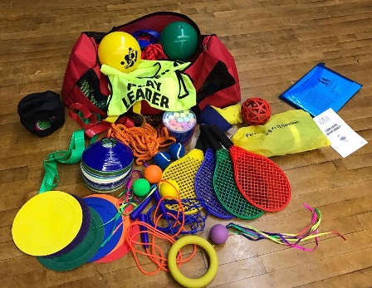
Order your Young Leaders Equipment Bag
Including everything you need to run a successful young leaders programme in your school; beanbags, playground chalk, balls, skipping ropes, hoops, rackets, activity cards, play leader bibs and more.
Available for the special price of £175

