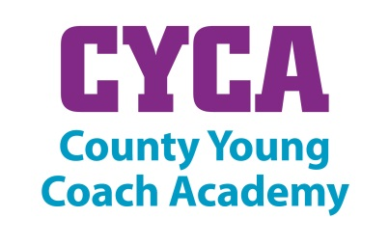

Coach Bursary Guidance Document
Purpose of Funding
The funding is to support young coaches living in Cambridgeshire and Peterborough that are enrolled on to the County Young Coach Academy (CYCA) to achieve a Level 1 coaching qualification or equivalent CPD/training course. The bursary will only be given to those young coaches that can commit to a minimum of 12 hours of volunteer coaching to support one or more of the following:

- Level 2 or Level 3 Sainsbury’s School Games competitions
- A primary school Change 4 Life sports club
- A secondary school extra-curricular sports club

Bursary Aims:
- To increase the number of qualified young coaches in Cambridgeshire and Peterborough.
- To increase the amount of coaching being offered to young people in schools.

Payment
The CYCA will fund up to 50% and a maximum of £150 of a Level 1 coaching qualification or equivalent CPD course that a young coach wishes to attend. The amount awarded is at the discretion of the CYCA committee. The bursary will only contribute towards the cost of the course itself. Transport, refreshments, equipment and any other additional costs will need to be covered by the applicant. Payment of the bursary will be made after the course has been completed and the CYCA committee receive a copy of the certificate.

Application Assessment
Young coaches can submit applications at any point throughout the year. The applications will be assessed by the CYCA committee. Applicants that are successful at this stage will be contacted by a member of the committee.

Submitting the Application
Applications can be submitted via post, email or in person. If submitting via post please send to Julie Pashley, South Cambs SSP, Comberton Village College, West Street, Comberton CB23 7DU or via email to jpashley@combertonvc.org
Young Coach Bursary Application Form

Name of Young Coach:

E-mail address:

Contact Telephone Number:

Course Name:

Course Date and Venue:

Course Cost:

- Please describe your current coaching activity.

- What benefits will your new coaching qualification bring to you?

- Please indicate how you are going to achieve your 12 hours volunteering.

Please advise who to make the bursary payment to……………………………………………………………………………

